PowerAmerica 2020 Virtual WBG Summer Workshop

This document provides an overview of to use the Remo platform to present at PowerAmerica’s virtual conference on August 4th & 5th. This document contains:
- What is Remo?
- How to Join:
- Navigating Remo:
  - Presentation Mode
    - Your presentation
    - Optimizing your view during others’ presentations
  - Networking Mode

If you have any questions, please contact Maddie Shea of Fountainworks: maddie@fountainworks.com or (706) 247-3971.

What is Remo?
Remo is a new virtual conference platform that aims to make the remote world feel natural and humanized. Our goal is to make sure speakers are as comfortable as possible navigating Remo. If you have a moment, here are some quick resources that provide an overview of the platform.
- PDF guide from Remo
- YouTube Video from Remo
- YouTube video from a third party, but more in-depth

As a speaker, you will have the permission to broadcast in presentation mode and have access to join the stage in conversation mode. Attendees, on the other hand, will not be able to broadcast in presentation mode, and will not have access to join the stage, unless the event manager/admin invites them to join the stage during presentation mode.

How to Join:
First, make sure your device is compatible – currently, Remo does not have an iOS or Android app, so you will need to join from a computer. Google Chrome is the preferred browser, though most major browsers will work as well. It also does not have a dial-in function, so it is important your audio works. Go to geartest.remo.co to test your device compatibility and audio/video.
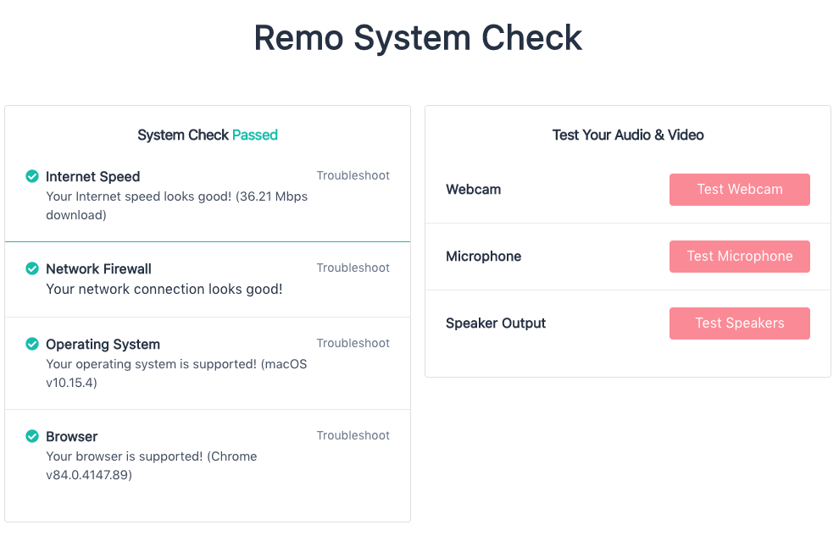

You will be added as a speaker by a member of our team. Look out for an email from noreply@remoinvite1.co with the subject line “Warren Miller invited you to PowerAmerica 2020 Virtual WBG Summit” – if you haven’t received an email by August 3rd, make sure it’s not in your spam folder. The invitation will look similar to this:

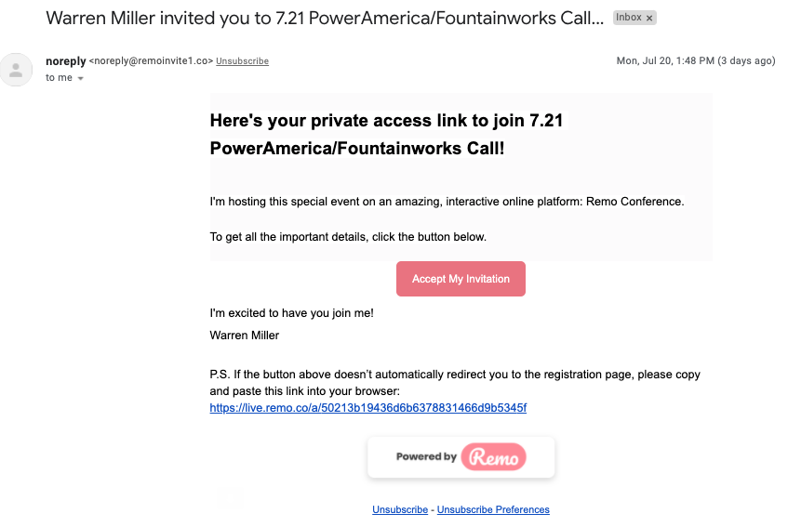

By clicking “Accept Invitation,” you will be taken to a landing page for the event. You’ll have to sign up using the same email address where you received the invitation. Until the event has begun, you will see a countdown timer on this landing page. Once the event has begun, you will be able to join by clicking the green button that says “Join event now!”

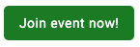

Navigating Remo
When you enter the event, at first you’ll see a pop-up welcome message. We encourage using headphones with a built-in microphone if available.

After you dismiss the welcome message, you will be brought into the conference room. We will be switching between two different “modes” over the course of the two-day event: Presentation Mode and Networking Mode. Depending on what time you enter the event in advance of your presentation, Remo might be in either mode.

Presentation Mode
We will be using Presentation Mode for the plenary segments of this two-day event.

It will look similar to this: 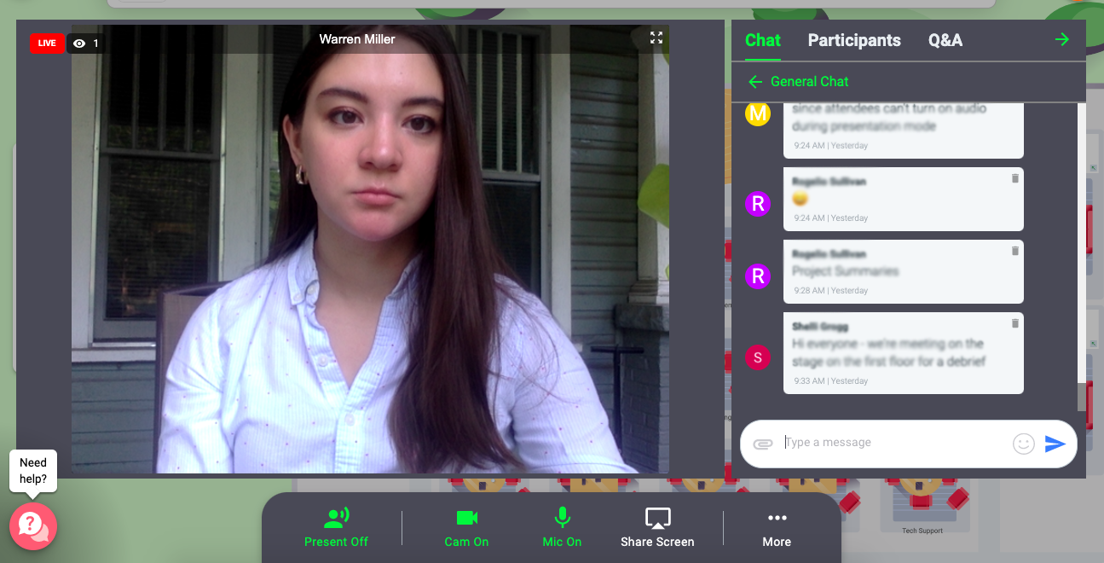

Present mode will have 4 main features.
- 1. Speaker windows: on the left half of the screen, the video from the speaker’s camera will be shown. If they are sharing a screen, it will also appear here.
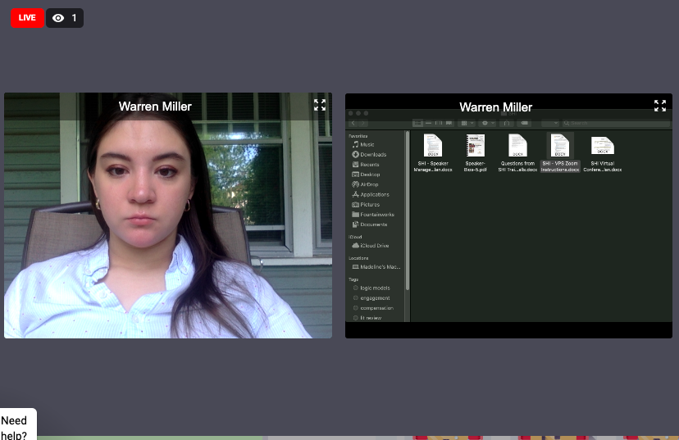
On the right side of the screen will be a window that contains the three other Presentation Mode features.
- 2. Chat: Remo’s chat function allows for a “General Chat,” private messaging (you can search a list of participants to find someone), as well as a chat with just the people at your table in Networking Mode.

- 3. Participants: A list of all participants will appear here.
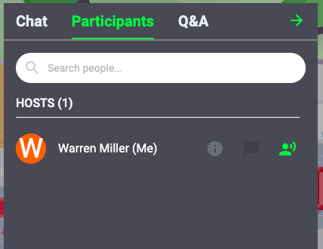

- 4. Q&A: While Remo does not have a polling feature, it does have a Q&A. Here, the host may mimic some polling questions and ask participants to “upvote” their choice. Also, this is where questions will appear for your own presentation. The moderator will ask questions after you have finished presenting your slides, and the host will dismiss them.
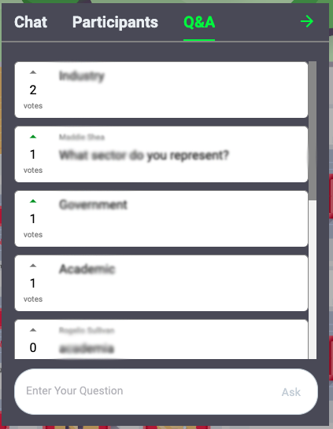

By clicking the green arrow, you can hide the right side and just see the speakers’ screen.
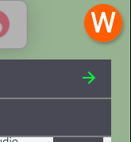

To change it back, just click the arrow pointing toward the left.
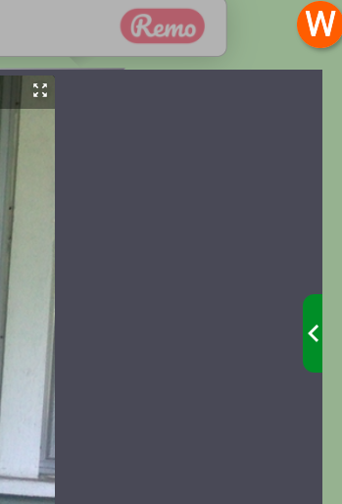

If someone is sharing their screen, by default, you will see both their camera and their shared screen at equal sizes. To view the slides/screen in full-screen mode, click the “Expand” icon at the top right of the screen you’d like to see.

Networking Mode
When you enter Remo, even if the event is in Presentation Mode, you will be randomly placed at a table. We will have six “floors” open for the event. Floors 1-3 are for general networking/sitting, and will be filled up first. Floors 4-6 are reserved for specific topics: student posters, project summaries, and WBG roadmap topics.

Remo is a visual top-down view, 2-D map comprised of interactive conference rooms on different floors. The app uses video, audio and chat to allow people within the space to interact naturally in real-time, from anywhere in the world.

It will look similar to this:
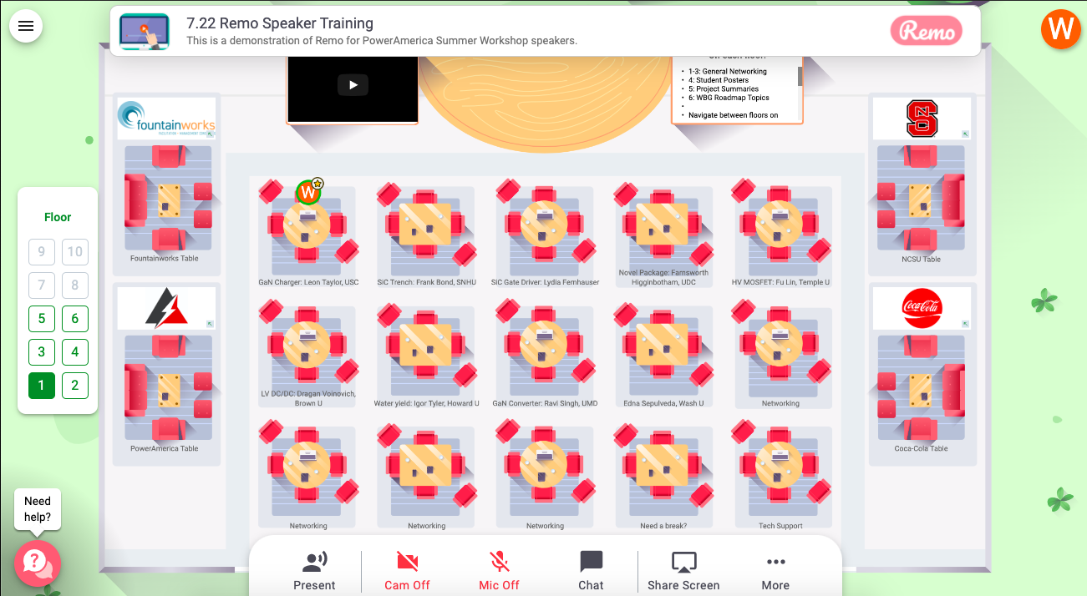

In between presentations, there will be a series of networking breaks and opportunities from
First, we encourage you to add your “Virtual Business Card.” In the top left corner, click the your initial icon, then “My Profile”:

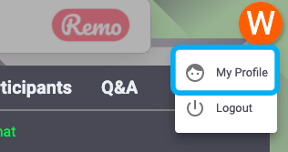

Your virtual business card will appear. Click “Edit Profile.” You can add your job title/company, company website, your LinkedIn, and a scheduling app such as Calend.ly for appointments.

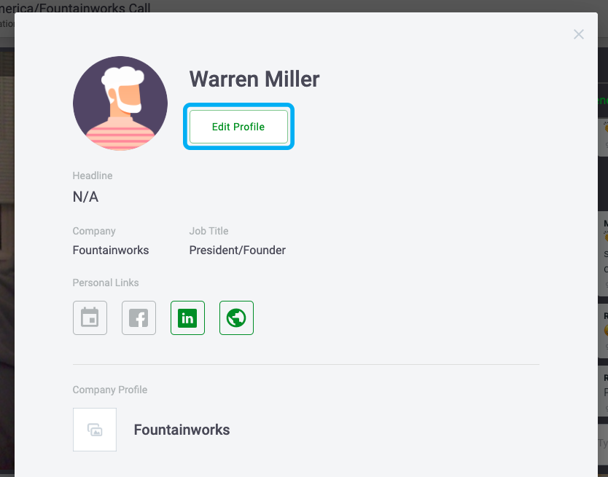

Enter your information, then make sure you “Save Changes.”
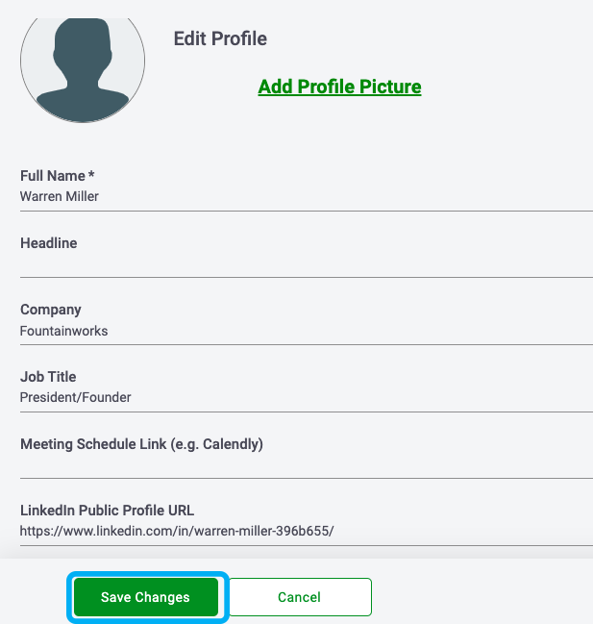

In Networking Mode, you will can change tables by double-clicking on the table you’d like to sit at. On each floor, the four side tables will be sponsored tables, with a representative from each respective organization on the first floor sponsor table. On Floors 4-6, tables will be labeled by student presenter or topic.

You are able to interact with everyone at your table with video and audio, and also share screens. Only those at your table can see it. Each person’s webcam video will appear at the top of your screen:
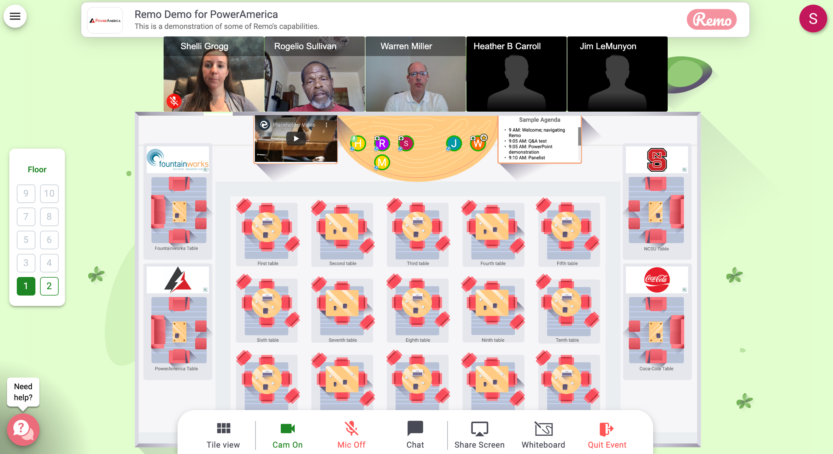

Each table sits a maximum of six people. We encourage those who need a break to move to one of the “Need a Break?” tables on each floor as to not take up space at a table where someone may be presenting. On each floor, we will also have a technical support table. Both the break and technical support tables will be at the bottom right of the conference room.

If you want to sit with someone in particular, click the Chat button and search for them. Then, you can send a private message to see which floor they are on or which table they are sitting at. You can navigate between floors while in Networking Mode by using the side “Elevator” buttons to the left of the conference floor:

On the top of the screen is a billboard with what is on each floor. You can expand the billboard by hovering your cursor over it:
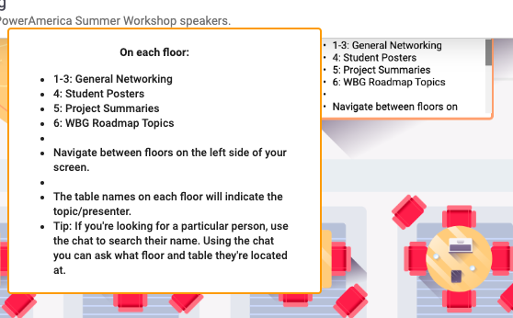

That’s it! If you have questions, please contact Maddie Shea at Fountainworks: maddie@fountainworks.com or (706) 247-3971. During the event, in Presentation Mode you can also private chat Maddie Shea or Technical Support. In Networking Mode, you can join the Technical Support table.

